Open radarWaveformAnalyzer App
When you type radarWaveformAnalyzer from the command line or select the app from the App Toolstrip, an interactive window opens. The default window shows a rectangular waveform and its spectrum. You can then select various options to analyze different waveforms.
radarWaveformAnalyzer
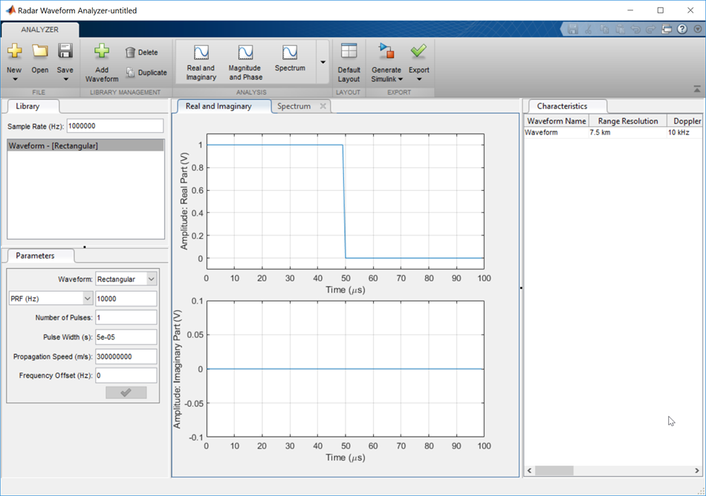

Show the spectrogram of baseband FMCW signal
As an example, use the app to show the spectrogram of a continuous FMCW waveform.
- Set the Waveform to FMCW
- Set the Sweep Interval to Symmetric
- Set the Number of Sweeps to 4
- In the Analysis tab, select Spectrogram
Then, you will see a plot of the spectrogram of the signal similar to this.
